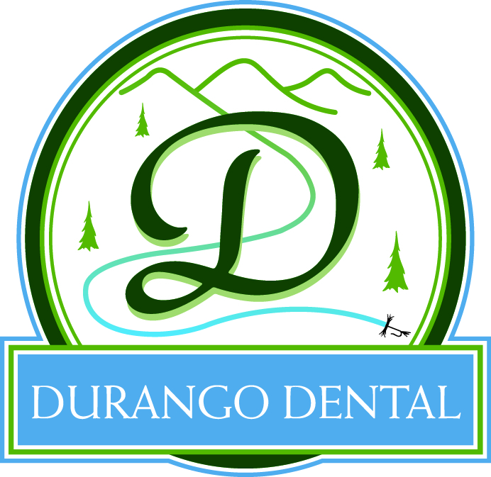
Brad A. Belt D.M.D
73 County Road 250
Durango, Co 81301
Cell Phone (719)-659-5118
DURANGO DENTAL FINANCIAL POLICY

Payments: Durango Dental does require payment in full for your portion at the time of service. With the exception of cleanings, this payment will be collected prior to services being rendered. We do require that any appointment that is being scheduled have a deposit made of $55.00 per hour to hold that reserved time. This deposit will be credited towards your treatment. We accept all major credit cards, cash and checks (checks are accepted only from existing patients with an established payment history). We also work with several third-party financers that offer a 6 to 12 month 0% interest payment plan with approved credit.
Broken Appointments: To cancel or change your appointment, we require a notice of 2 BUSINESS DAYS. This means if you have made a deposit to reserve a time slot and have cancelled within the 48 hour window, your deposit will be forfeited. Cleanings, where no deposit was required, will receive a $55 cancellation or missed appointment fee.
Insurance: Your insurance coverage is based upon a contract made between your employer and insurance company. If you have any questions that we are not able to assist you with, please contact your employer or dental insurance company directly. Dental benefit plans are only made to assist you with your dental needs, not pay for it completely.
We currently accept all private care insurance plans. We work with hundreds of insurance companies and although we keep a history of payments, they change. This makes it impossible to give you a guaranteed quote at the time of service. We estimate your portion based on the most up-to-date information but it is only an ESTIMATE.
We bill your insurance company as a courtesy. If insurance does not pay within 60 days Durango Dental reserves the right to request in full for services from you and let you collect the insurance funds that are due to you. Ultimately, you are responsible for all charges incurred in our office.
We welcome you to our family and look forward to helping you get the healthy, beautiful smile you’ve always wanted. If there is anything we can do to make your visits here more pleasant, please don’t hesitate to ask one of our staff members.

Name of Patient(s)________________________________________________________________________________
Signature of Patient____________________________ _______________________Date_______/_______/________

